STEPS FOR CHANGING TAC PASSWORD
*********************
Keep these notes handy. Eschool requires you change your password every 90 days. You will not get a prompt to do so, you will just not be able to log in one day.
*********************

Go to apscn.org and click on Security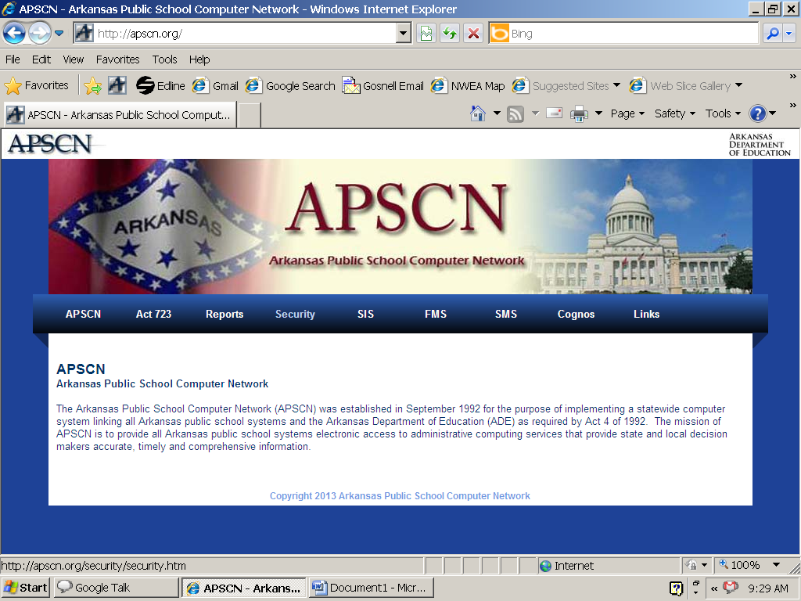

Click on Security Resources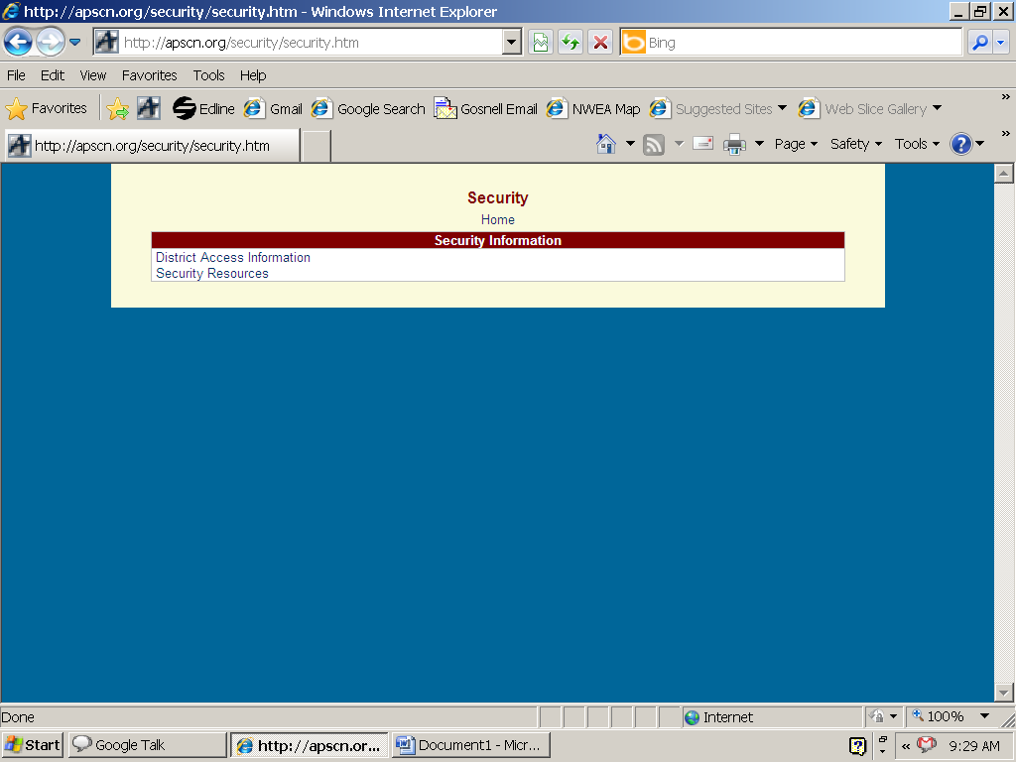

Click on ADE Single Sign in/Sign On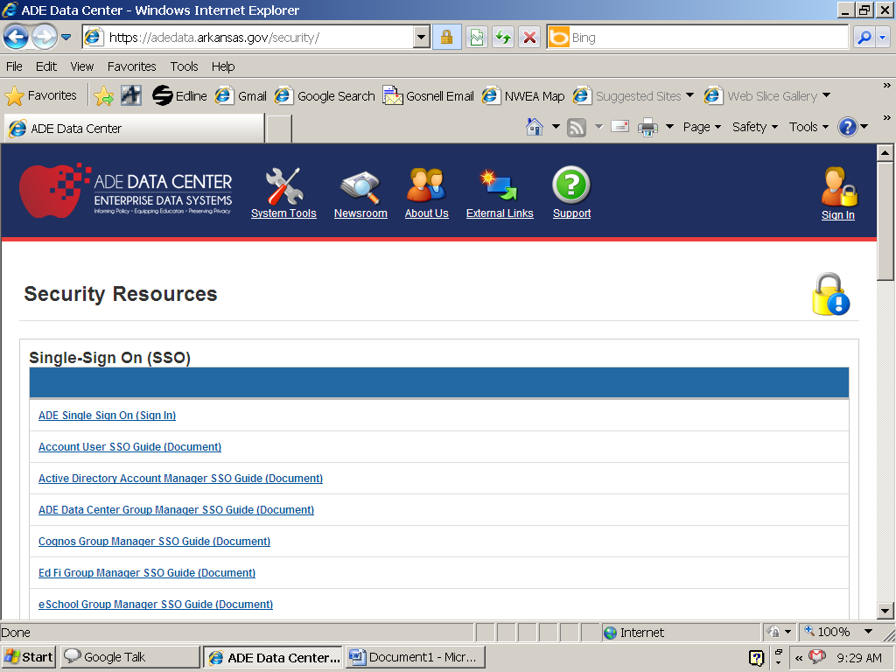

Enter 4708 plus your username and your OLD password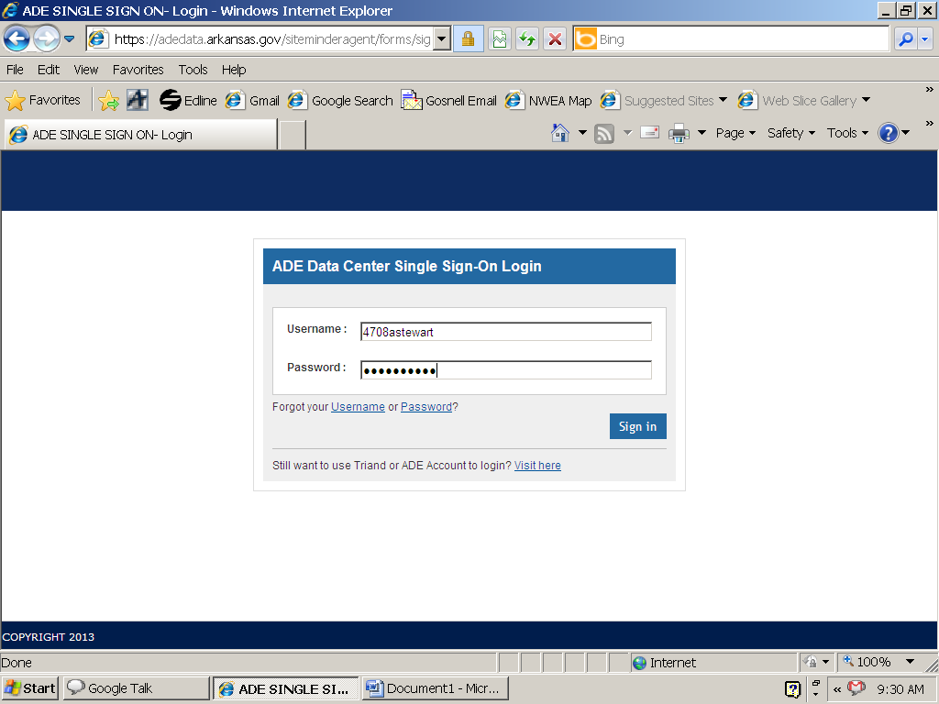

Click on the SSO Account Settings box
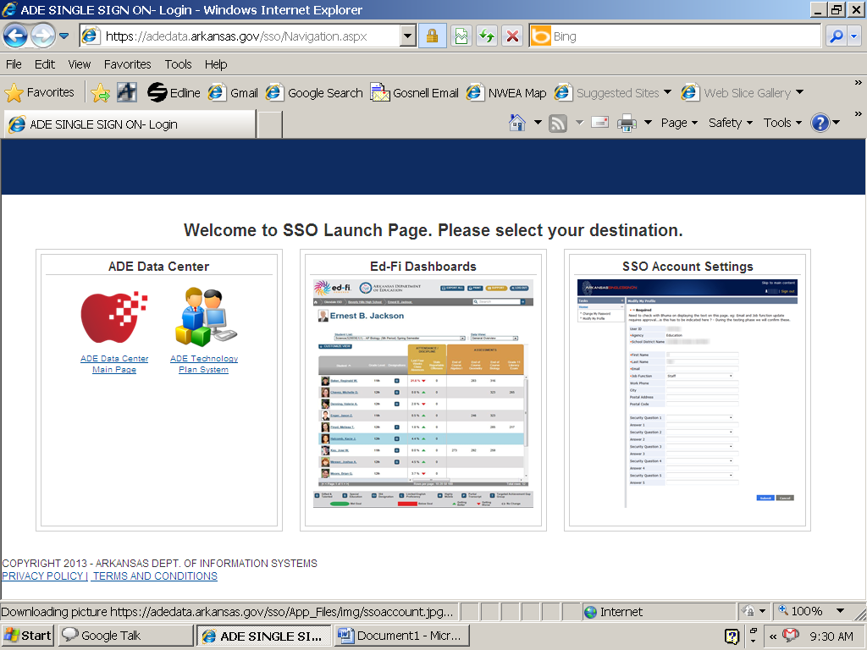
Click on Change My Password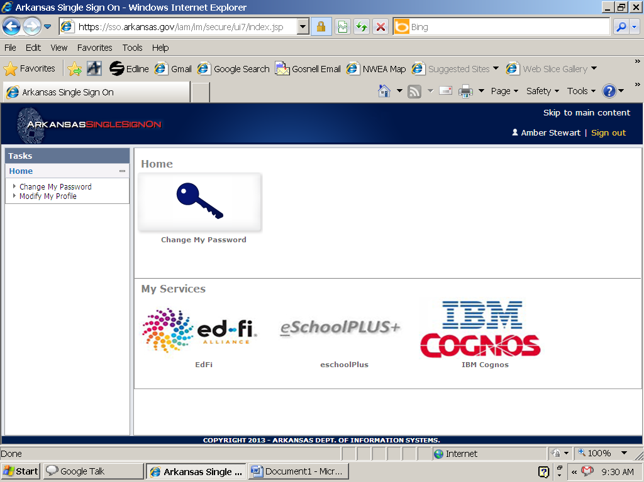

Enter your new Password
Note the requirements MUST be met
